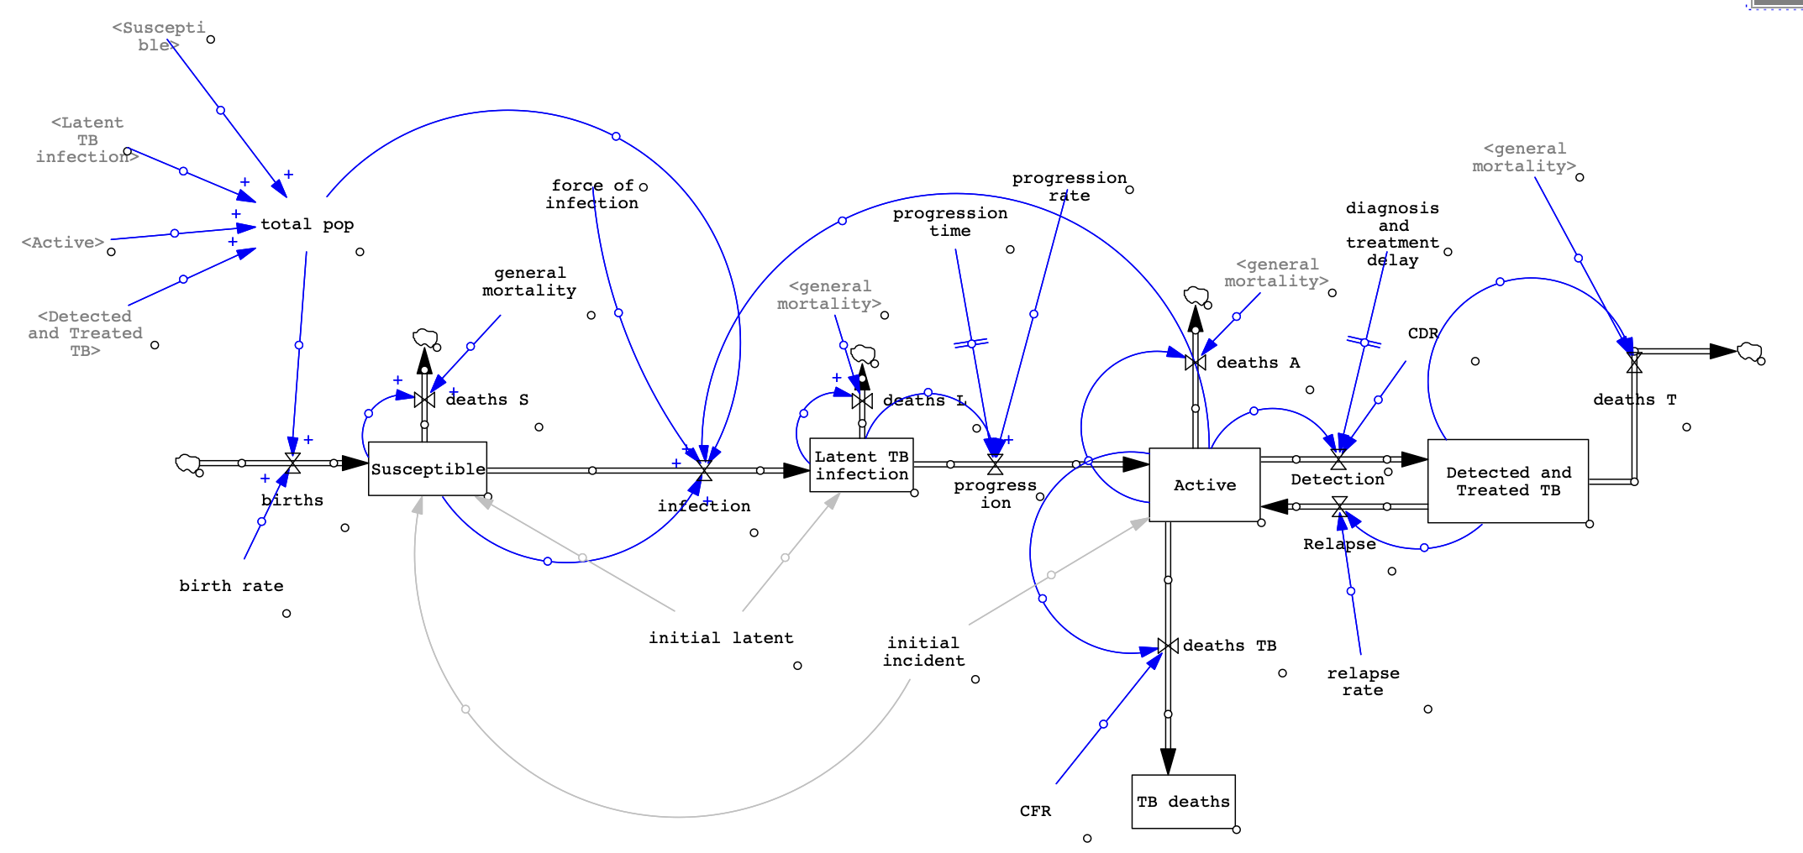

**Table: Vensim Stocks and Flows**

|  |  |  |  |  |
| --- | --- | --- | --- | --- |
| **Model Component** | **Description** | **Type** | **Formula** | **Initial conditions and units** |
| Susceptible | The number of individuals who have never been infected with TB | Stock | $$Births-Infection-deaths S$$ | **IC:** 3.8e+07-*initial incident*-*initial latent*  **Units**: People |
| Latent TB infection | Individuals infected with TB, but are not infectious or symptomatic | Stock | $$Infection-progression-deaths L$$ | **IC:** *Initial Latent*  **Units:** People |
| Active | Individuals with TB disease who are symptomatic and infectious | Stock | $$Progression+relapse-Detection-deaths TB-deaths A$$ | **IC:** *Initial Incident*  **Units:** People |
| Detected and Treated TB | Individuals who have been diagnosed and treated for TB | Stock | $$Detection-Relapse-deaths T$$ | **IC:** 55000  **Units:** People |
| TB deaths | Number of individuals who have died from TB disease | Stock | $$deaths TB$$ | **IC:** 0  **Units**: People |
| Total Pop | Total number of living individuals | Auxiliary | $$Active+Detected and Treated TB+Latent TB infection+Susceptible$$ | **Units:** People |
| Births | Number of births each month | Flow | $$birth rate*total pop$$ | **Units:** People/Month |
| Infection | Number of susceptible individuals infected with TB each month | Flow | $$Force of infection*Susceptible*(Active/total pop)$$ | **Units:** People/Month |
| Progression | Number of individuals infected with TB who progress to active TB each month | Flow | $$DELAY1(Latent TB infection,$$ $$progression time)*progression rate$$ | **Units:** People/Month |
| Detection | Number of individuals diagnosed and treated for TB each month | Flow | $$DELAY1( Active ,d$$ $$iagnosis and treatment delay )*CDR$$ | People/Month |
| Relapse | Number of previously diagnosed individuals who acquire active TB again per month | Flow | $$Detected and Treated TB*relapse rate$$ | People/Month |
| Deaths TB | Number of individuals with active TB who die as a result of TB per month | Flow | $$Active*(\frac{CFR}{12})$$ | People/Month |
| Deaths S | General deaths in the susceptible population per month | Flow | $$Susceptible*general mortality$$ | People/Month |
| Deaths L | General deaths in the latently infected population per month | Flow | $$Latent*general mortality$$ | People/Month |
| Deaths A | General deaths in the active TB population per month | Flow | $$Active*general mortality$$ | People/Month |
| Deaths T | General deaths in the diagnosed and treated population per month | Flow | $$Detected and Treated TB*general mortality$$ | People/Month |